## CSS:

1. True or false? 🡺When you want to style set of documents with same style, it’s better to use External CSS (**True**) (quiz 2020)
2. How can we use CSS?

**Answer:**

* **Inline** – apply style attribute to a single tag
* Take a lot of work to maintain across a website.
* **Internal** – stylesheet defined in the <head> tag of a page
* Cleaner way than the inline.
* **External** – style sheet (a .css text file)
* The most preferred. (reusability – cleaner html code – easier to maintain).

1. (& Exam Model 2 Q.2.2 & Model 4 Q.2.3.2)
2. Write a style sheet that expresses that **H1** and **H2** should always be **centered** and always be **red**.
3. Add a rule for a **class bGreen** that defines text in **bold** and **Green**.

**h1,**

**h2 {**

**text-align: center;**

**color: red;**

**}**

**.bGreen {**

**font-weight: bold;**

**color: green;**

**}**

1. What is CSS, list Advantages.

**Answer:**

**What is CSS:**

* **Cascading Style Sheets (CSS)** is a style sheet language used for describing the presentation of a document written in a markup language like HTML.

**Advantages**:

* Cleaner html code (CSS can be in a separate file) (External CSS).
* Separates styles from html tags and page content and make styles reusable in any page or website.
* Consistent look across entire website & Easier to maintain (changing style in one places).

**Disadvantages**:

* Not uniformly supported by all browsers.

1. Explain 2 different ways that CSS supports the **DRY** principle.

**Answer:**

* Elements with the same class can share a single copy of styles.
* Styles can be inherited by child elements from their parents.
* Stylesheets can be shared between Web pages.

1. What are the major advantages of using an external CSS file in Web Pages? If your CSS doesn’t set the width and height of an element, how is the width and height of that element determined?

**Answer:**

**Advantages**:

* Can be reused across webpages.
* Cleaner html code (separate styles from html tags).
* Easier to maintain as we apply styling changes in one place.

**If we didn’t specify width and height**:

* If the element has content:
* For block elements: the width will fill its parent and the height will grow to fill the content height.
* For inline elements: the width and height will grow to fit its content.
* If the element has no content:
* For block elements: the width will fill its parent, and height will be zero.
* For inline elements: the width and height will be zero.

1. What is CSS? What are the major advantages of using an external CSS file in Web Pages?

**Answer:**

* **Cascading Style Sheets (CSS)** is a style sheet language used for describing the presentation of a document written in a markup language like HTML.
* **External CSS** can be applied to multiple documents while being managed from a single style sheet. This keeps code **DRY** and improves efficiency and convenience.

1. Write two CSS files **sty1**, **sty2**, for **Blue theme** and **Grey theme**.

**Answer:**

1. Write [HTML](https://elearning.mti.edu.eg/mod/resource/view.php?id=1602) tags show how to use alternate styles and printed version.

**Answer:**

**Important notes for CSS:**

* **You should know how to use Classes and ids in CSS.**
* 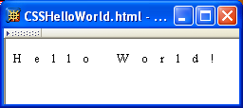**Letter spacing:**

**p {**

**font-size: smaller;**

**letter-spacing: 1em;**

**}**

* **Printing CSS version:**
* We can make a colorful style for displaying website on the screen, while keep colors in black and white in printing mode.

**<link rel="stylesheet" type="text/css" href="style1.css" media="screen, tv, projection" />**

**<link rel="stylesheet" type="text/css" href="style2.css" media="handheld, print" />**

* **Alternate Stylesheet:**
* Use cases 🡪 **different themes (without using js)**.
* Can be Changed from the “**view**” tab:

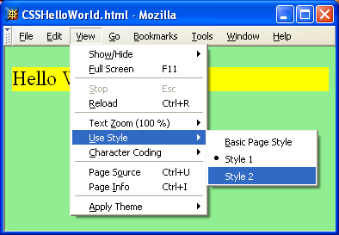

**<!DOCTYPE html>**

**<html lang="en">**

**<head>**

**<title>Document</title>**

**<link rel="stylesheet" type="text/css" href="style1.css" title="Style 1" />**

**<link rel="alternate stylesheet" type="text/css" href="style2.css" title="Style 2" />**

**</head>**

**<body></body>**

**</html>**

1. Consider the following HTML code: (& Exam Model 3 Q.5.1)

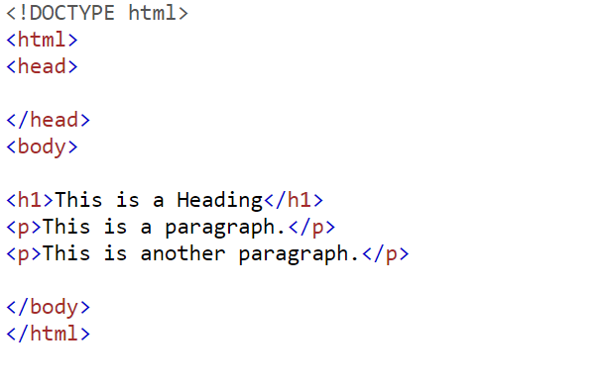

1. Add an external style sheet with the URL: "mystyle.css".
2. Set "background-color: linen" for the page, using an internal style sheet.
3. Set "background-color: Yellow" for the page, using an inline style.

**Answer:**

**<!DOCTYPE html>**

**<html>**

**<head>**

**<title>CSS</title>**

**<!-- Adding external CSS-->**

**<link rel="stylesheet" href="mystyle.css" />**

**<!-- internal CSS -->**

**<style>**

**body {**

**background-color: linen;**

**}**

**</style>**

**</head>**

**<!-- inline CSS -->**

**<body style="background-color: yellow;">**

**<h1>This is a Heading</h1>**

**<p>This is a paragraph</p>**

**<p>This is another paragraph</p>**

**</body>**

**</html>**